Reading Emojis

Short Sentences
Look at the following scenes. How would you translate them into English? Write short sentences.

1 |  | __________________________________________  __________________________________________
2 |  | __________________________________________  __________________________________________
3 |  | __________________________________________  __________________________________________
4 |  | __________________________________________  __________________________________________
5 |  | __________________________________________  __________________________________________
6 |  | __________________________________________  __________________________________________
7 |  | __________________________________________  __________________________________________
8 |  | __________________________________________  __________________________________________

Text excerpts
- Translate the following text into English using full sentences. Write your text on the lines below. Them compare your text with a partner. Does s/he have a similar result?

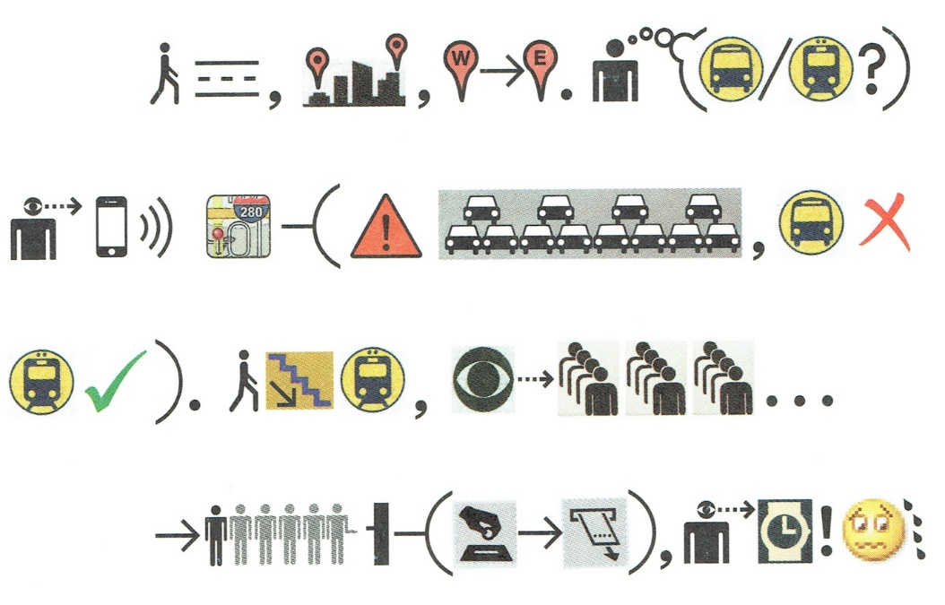

___________________________________________________________________________
___________________________________________________________________________
___________________________________________________________________________
___________________________________________________________________________
___________________________________________________________________________
___________________________________________________________________________
___________________________________________________________________________
___________________________________________________________________________

- Let’s try one more.
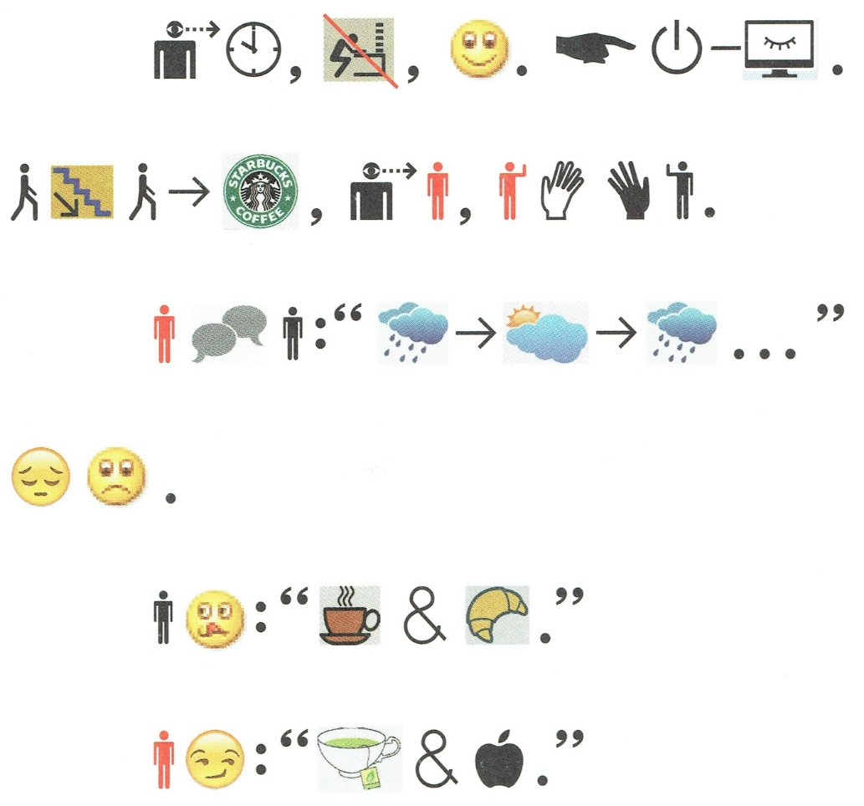

___________________________________________________________________________
___________________________________________________________________________
___________________________________________________________________________
___________________________________________________________________________
___________________________________________________________________________
___________________________________________________________________________
___________________________________________________________________________
___________________________________________________________________________

Your weekend
Go to https://www.icon-stories.ch/editor.php and write about what you did last weekend. Follow questions 1-5. When you’re finished, swap your text with your partner’s. You’re going to read his/her text out loud. She or he will do the same with yours.

- What did you do in the morning?
- What did you at noon?
- What were your plans after that?
- How did you spend your evening?
- Answer questions 1-4 about your Sunday.

